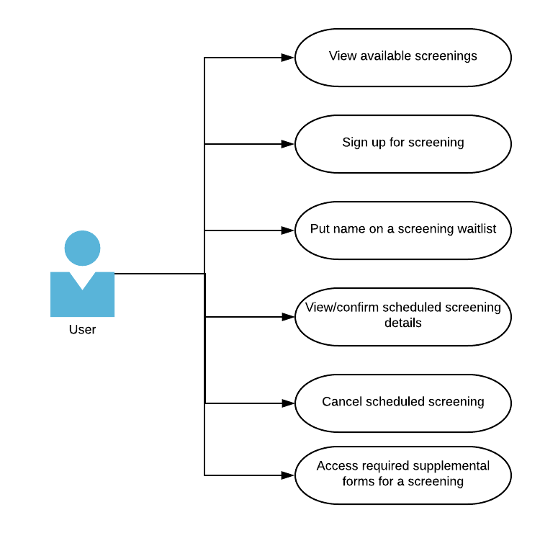

A User Use Case Diagram describing the different uses of the system for a Screening Client User.